Chase Lotito
ECE426 – Chao Lu
Lab 4: 4-bit Subtractor Design

FullAdder.v
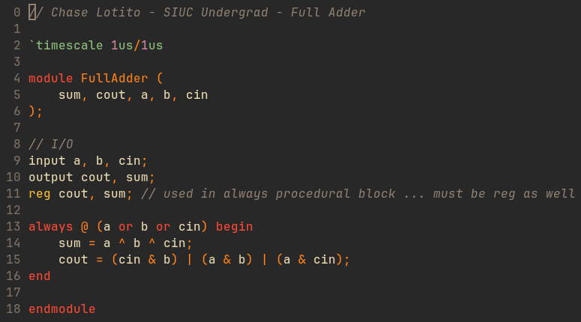
adder-subtractor-struct-4b.v
// Chase Lotito - SIUC - SP2024
// ECE426 - VLSI Lab
// Lab 4: Subtractor Design
// MODULE: 4-bit Adder-Subractor

`timescale 1us/1us
`include "FullAdder.v"

module adder_subtractor_struct_4b (
a, b, m, rslt, cout, ovf
);

// I/O
input [3:0] a, b; // 4-bit inputs
input m; // mode control
output [3:0] rslt, cout; // 4-bit result and carrys
output ovf; // overflow bit

// Intermediary Wires
wire net0, net1, net2, net3;

////////////////
// GATE-LEVEL //

// overflow
xor xor0 (ovf, cout[2], cout[3]);

// FA0 section
xor xor1 (net0, m, b[0]);
FullAdder FA0 (
.sum(rslt[0]),
.cout(cout[0]),
.a(a[0]),
.b(net0),
.cin(m)
);

// FA0 section
xor xor2 (net1, m, b[1]);
FullAdder FA1 (
.sum(rslt[1]),
.cout(cout[1]),
.a(a[1]),
.b(net1),
.cin(cout[0])
);

// FA0 section
xor xor3 (net2, m, b[2]);
FullAdder FA2 (
.sum(rslt[2]),
.cout(cout[2]),
.a(a[2]),
.b(net2),
.cin(cout[1])
);

// FA0 section
xor xor4 (net3, m, b[3]);
FullAdder FA3 (
.sum(rslt[3]),
.cout(cout[3]),
.a(a[3]),
.b(net3),
.cin(cout[2])
);
endmodule
tb.v
// Chase Lotito - ECE426 Lab 4 - Testbench

`include "adder-subtractor-struct-4b.v"
`timescale 1us/1us

module tb();

// GTKWAVE
initial begin : GTKWAVE
$dumpfile("lab4.vcd");
$dumpvars(0, tb);
end

reg [3:0] a, b;
reg m;
wire [3:0] rslt, cout;
wire ovf;

initial //display variables

$monitor ("[%3t ns] a=%b, b=%b, m=%b, rslt=%b, cout[3]=%b, cout[2]=%b, ovf=%b", $time, a, b, m, rslt, cout[3], cout[2], ovf);

initial //apply input vectors

begin

//addition
#0 a = 4'b0000; b = 4'b0001; m = 1'b0;
#10 a = 4'b0010; b = 4'b0101; m = 1'b0;
#10 a = 4'b0110; b = 4'b0001; m = 1'b0;
#10 a = 4'b0101; b = 4'b0001; m = 1'b0;

//subtraction
#10 a = 4'b0111; b = 4'b0101; m = 1'b1;
#10 a = 4'b0101; b = 4'b0100; m = 1'b1;
#10 a = 4'b0110; b = 4'b0011; m = 1'b1;
#10 a = 4'b0110; b = 4'b0010; m = 1'b1;

//overflow
#10 a = 4'b0111; b = 4'b0101; m = 1'b0;
#10 a = 4'b1000; b = 4'b1011; m = 1'b0;
#10 a = 4'b0110; b = 4'b1100; m = 1'b1;
#10 a = 4'b1000; b = 4'b0010; m = 1'b1;

#10 $finish;

end

adder_subtractor_struct_4b inst1 ( //instantiate the module
.a(a),
.b(b),
.m(m),
.rslt(rslt),
.cout(cout),
.ovf(ovf)
);

endmodule
Simulation Output Log

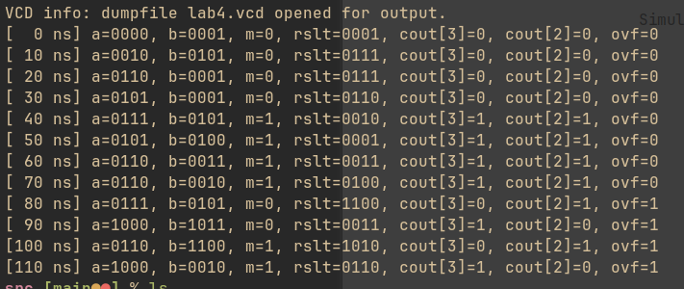
Waveforms
